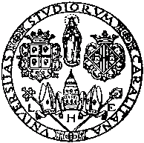

UNIVERSITÀ DEGLI STUDI DI CAGLIARI

Doctoral Course (2023)

- Title

Introduction to modal logic

orientamento alla ricerca

- Lecturer (I)

Antono Ledda (antonio.ledda@unica.it)

- Hours
14

- (CFR)

- Place

Via Is Mirrionis 1, Cagliari, Room 35, main building

- Timings
February 2024;

The interested persons are warmly invited to contact me in order to discuss convenient dates and hours!

T
- Descripription
We will provide a concise introduction to the fundamentals of modal logic. In detail,

The language of modal logic
Logics and normal logics.
Semantics of modalities.
Modal logic and first order conditions.
Canonical models.
Filtrations and models.
Examples and applications.

- References

Alexander Chagrov and Michael Zakharyaschev, Modal Logic, Oxford Univ. Press, 1997.

